Assignment-3

Assignment 3: Create a function that takes a filename as an argument and prints the number of lines in the file. Call this function from your script with different filenames.

Shell script code with the name of count_lines.sh:
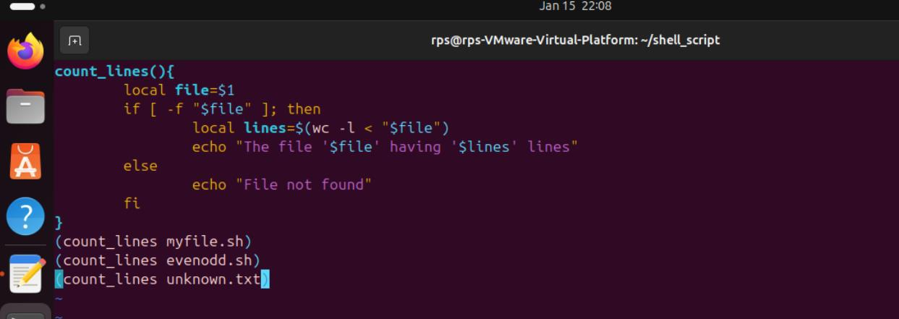

Commands to run count_lines.sh and checking its function:
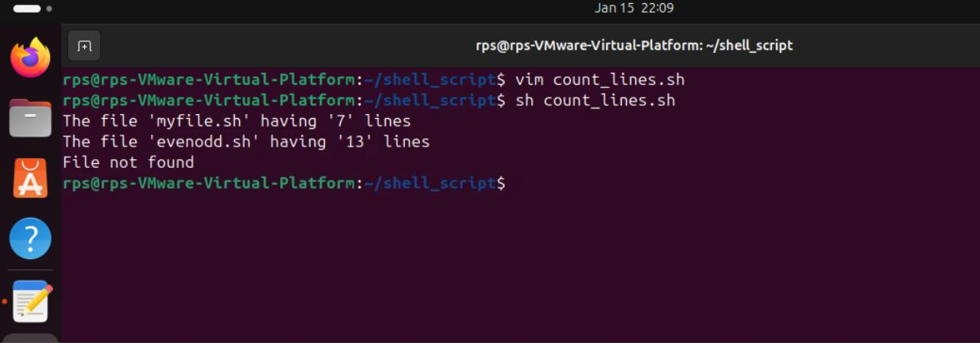

21958-Lokesh_Panem

